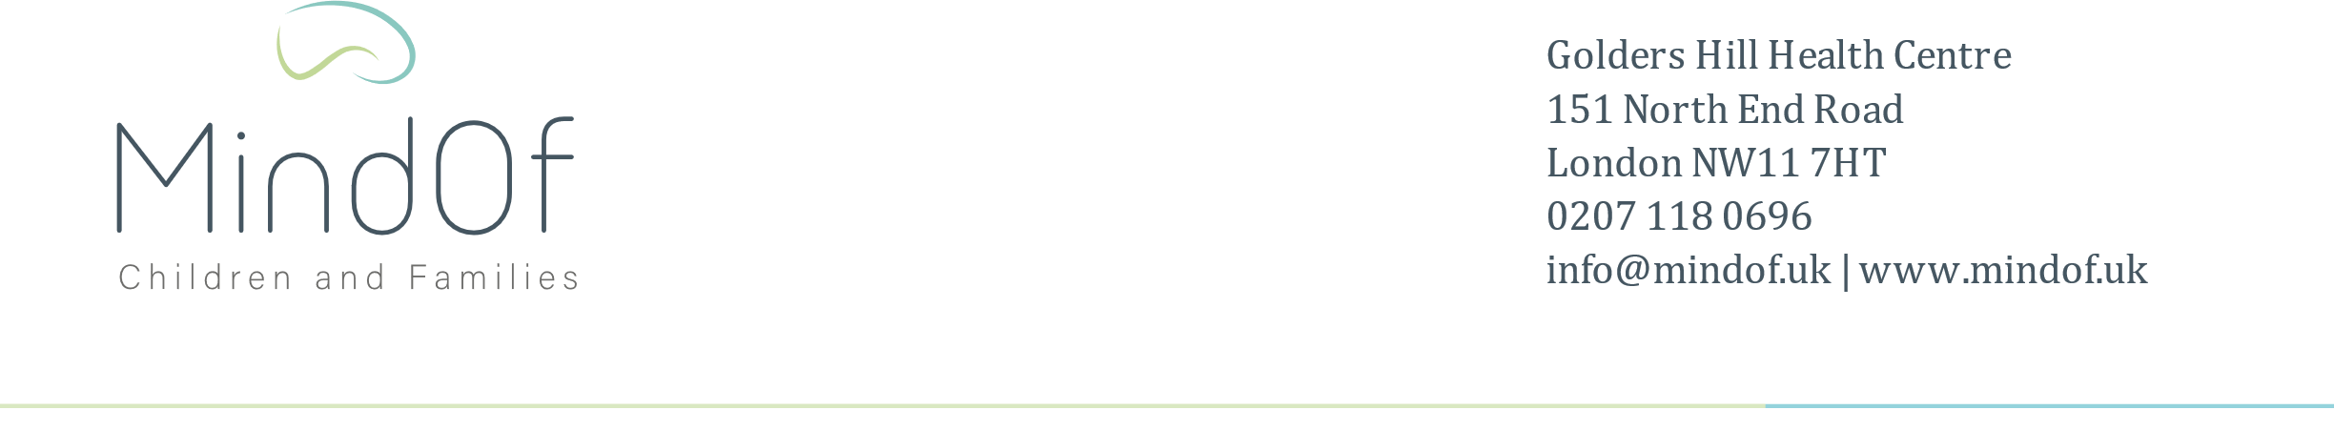

**NEW PATIENT BOOKING QUESTIONNAIRE**

Below is a short questionnaire to establish whether we are the right service for you and so we can ensure we provide the right advice and book the most appropriate assessment type to support you appropriately.

|  |  |  |
| --- | --- | --- |
| A. What is the reason for your seeking our services? | | |
| B What is the assessment you require? (PLEASE TICK ONE)  *ADHD Assessment ASD Assessment*  *General Psychiatric Assessment*  *(other emotional /behavioural difficulties/already has an ADHD or ASD diagnosis)*  Psychological Therapy Sessions  Speech and Language Assessment  Selective Mutism Assessment | | |
| C.   What is the age of your child? |  | |
|  | Yes | No |
| E.  1. Is your child able to engage in an assessment /review? |  |  |
| 2. Does your child have an eating disorder/eating disorder symptoms/is your child restricting their dietary intake? |  |  |
| 3. Is your child/family currently under the care of social services/ CAMHS? Has your family been referred to social services/ CAMHS either now or in the past? |  |  |
| 4.  Is your child experiencing hallucinations or delusions (odd beliefs)? |  |  |
| 5.  Is your child actively abusing alcohol and /or narcotics beyond recreational use? |  |  |
| 6.  Is your child actively suicidal with intent to act on these thoughts or made a recent suicide attempt? Are there any previous suicide attempts? |  |  |
| 7.  Is your child self-harming beyond superficial cuts/burns? |  |  |
| 8.  Does your child have a severe learning disability? |  |  |
| 9.  Is your child displaying aggressive behaviour requiring or that has required police involvement? Are forensic services involved with your child?  Have any been involved in the past? |  |  |

If you have answered **yes** to any of the above questions, please elaborate: